DATABASE SYSTEMS ENGINEERING AND DISTRIBUTED BACKEND DEVELOPMENT(25CS1302E)

2520030583 -
M.Thanishka
LAB MANUAL

- A working REST API running on day one — students issue HTTP requests with curl and Postman and observe the round trip before any internals.The canonical backend stack: HTTP server → routing/middleware → service layer → data-access layer → ORM/JDBC → SQL → storage engine → filesystem.REST as a discipline: resources, HTTP verbs, status codes, idempotence, statelessness; the contract a backend exposes to its clients.Spring Boot at intro level: the @RestController, @Service, @Repository layering; dependency injection at use-site, not theory.

Case Study: Student Management REST API
- Develop a REST API to manage students in a college. The API should allow clients (Postman/cURL) to perform CRUD operations.

Project Structure:
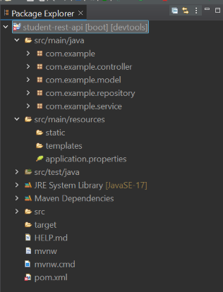

STEP1:
Add Dependencies in pom.xml file and save the file
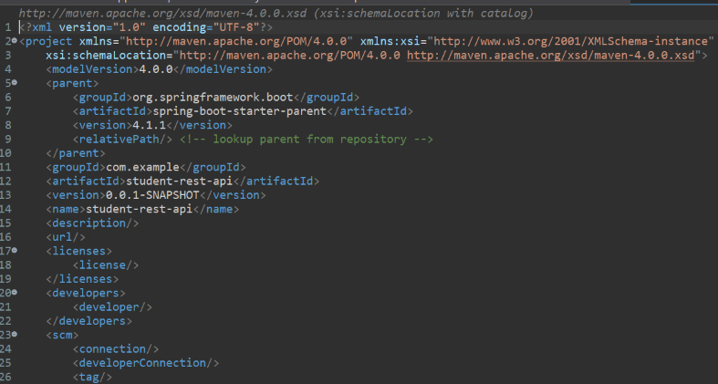
Step 2:
In application.properties file,
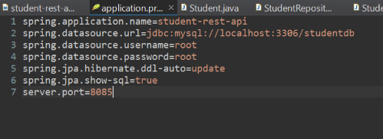
Step 3:
Create Packages, Model, Controller, Service, Repository in src/main/java
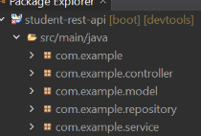

Step 4:
In com.example.model Layer, create the class file student.java and save it

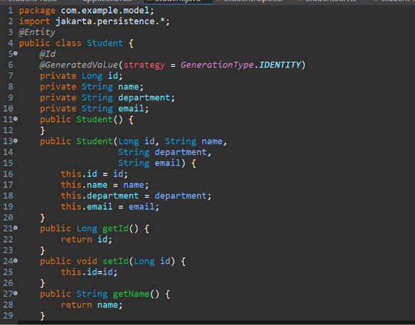
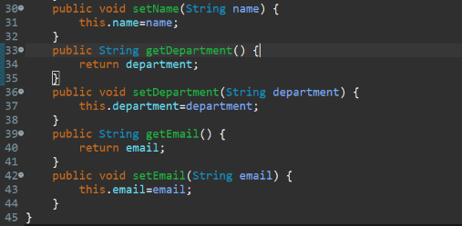
}

Step 5:
Create class file StudentService.java in com.example.Service Layer and save it.
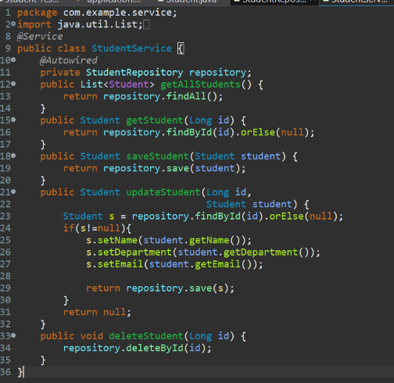
Step 6:
Create class file StudentController.java in com.example.Controller Layer and save it.

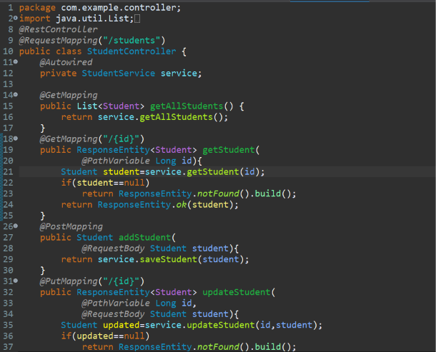
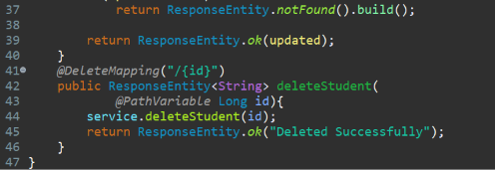
Step 7:
Create class file StudentRepository.java in com.example.Repository Layer and save it.

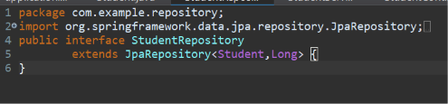
Step 8:
- Start MySQL Server

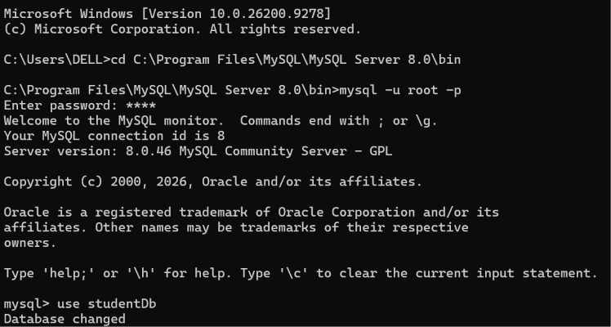

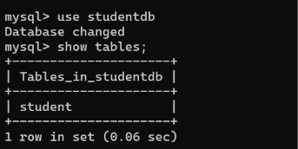
Step 9:
Run as SpringBoot App
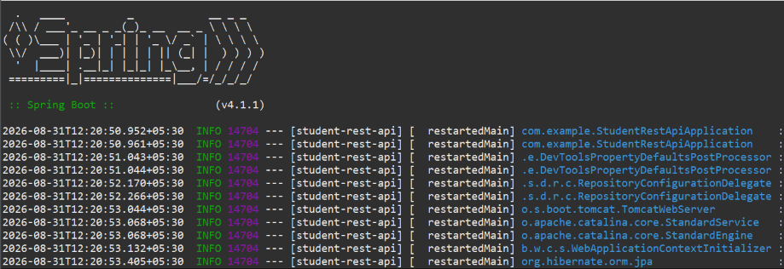
Step 10:
Open Postman app,
Testing GET method with Postman
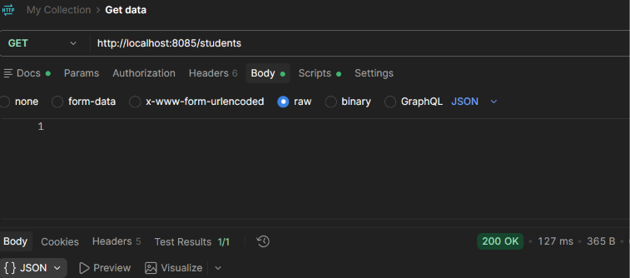

Since there are no data in the table, it returned empty braces.
Testing POST method with Postman

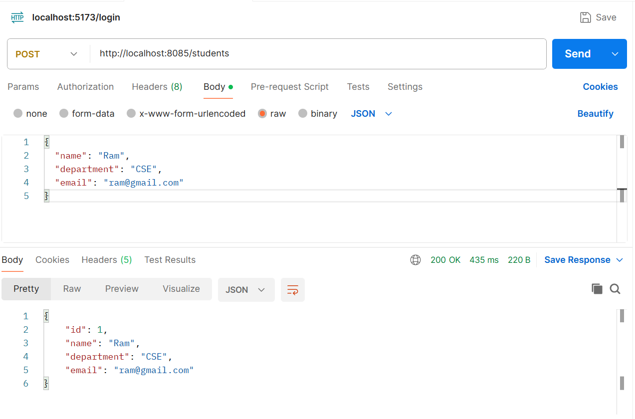
Now, inserted on row into the table using POST method. Test it with GET method to retrieve the data.

Step 12:
Now test it with MySQL Server
- Use Studentdb;
- Show Tables;
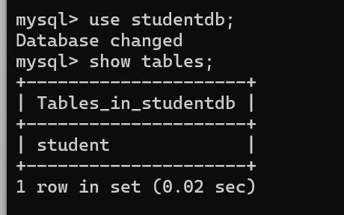

- Now verify, whether the row inserted using POST method in POSTMAN is visible in Database.
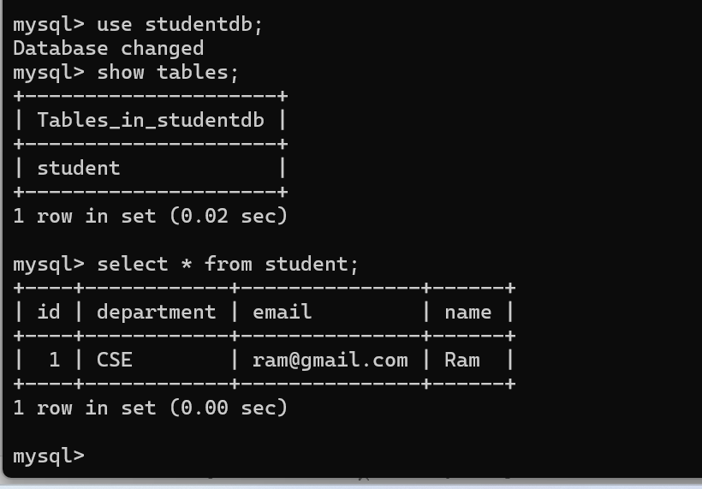
Likewise test other methods PUT and DELETE.
Run in Command Prompt:
Create a student:
Check all the students details:
